EXPERIMENT-06 DHILIPAN M
21/07/2026 192411038

VACUUM CLEANER PROBLEM USING A SIMPLE REFLEX AGENT.

AIM:
To write a Python program to simulate the Vacuum Cleaner Problem using a Simple Reflex Agent.
ALGORITHM:
Step 1: Read the status (Clean/Dirty) of Room A and Room B from the user.
Step 2: Place the vacuum cleaner initially in Room A.
Step 3: Check the current room. If it is Dirty, clean it.
Step 4: Move to the next room and repeat the cleaning process.
Step 5: Continue until both rooms are clean.
Step 6: Display the cleaning actions performed and the final status of both rooms.
PROGRAM:
rooms = {
"A": input("Enter status of Room A (Clean/Dirty): "),
"B": input("Enter status of Room B (Clean/Dirty): ")
}
location = "A"
while True:
if rooms[location].lower() == "dirty":
print("Cleaning Room", location)
rooms[location] = "Clean"
else:
print("Room", location, "is already Clean")
if location == "A":
location = "B"
else:
break
print("\nFinal Room Status:")
for room in rooms:
print("Room", room, ":", rooms[room])

OUTPUT:

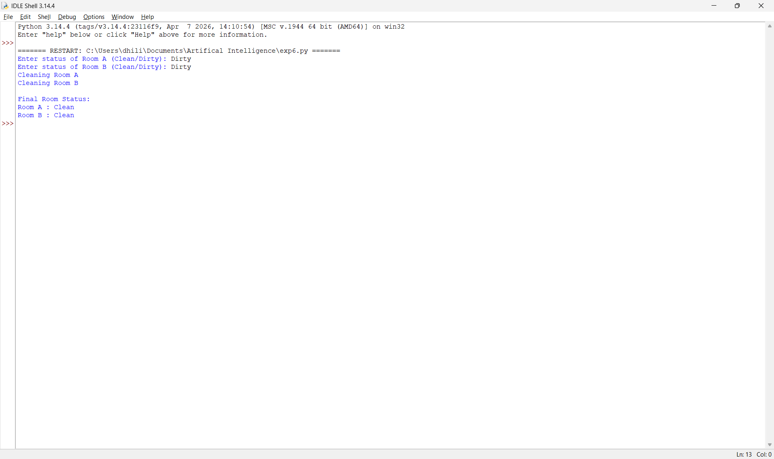

RESULT:
Thus, the Python program to simulate the Vacuum Cleaner Problem using the Simple Reflex Agent was implemented successfully and the required output was obtained.

